**RMIT University**

**EEET2582 | Software Engineering: Architecture and Design**

**Charitan Donation Platform Milestone 1 Report**

Student name & ID: ***Vo Duc Tan* *s3817693***

***Tran Thanh Tu s3957386***

***Tran Vinh Trong s3863973***

***Hur Hyeonbin s3740878***

***Bui Hong Thanh Thien s3878323***

Lecturer: ***Dr. Tri Huynh***

Contents

I. Introduction: 3

II. Project Background: 3

III. Concept Data Model: 4

1. ER Model(Thien): 4

2. Data Model Design Rationale: 5

IV. System Architecture: 5

1. Overall System Architecture(hb): 5

2. Backend Architecture(Trong): 5

3. Frontend Architecture(HB): 6

V. Architecture Analysis: 10

1. Maintainability: 10

2. Extensibility: 11

3. Resilience: 11

4. Scalability: 11

5. Security: 11

6. Performance: 11

VI. Conclusion: 11

VII. References: 11

# Introduction:

In our increasingly interconnected world, the influence of collective goodness can significantly affect communities and individuals in need. Charitan serves as a dynamic and comprehensive platform that connects funders, volunteers, and charitable projects globally. Charitan seeks to leverage technology to establish a cohesive and engaging experience for all users, promoting significant connections and encouraging a culture of generosity.   
  
The platform is founded on two principal objectives. Initially, to aid donors and volunteers in identifying and supporting charitable efforts that align with their ideals, whether local or global. Charitan enables individuals to make informed decisions regarding the optimal allocation of their contributions for maximum impact. Secondly, Charitan equips organizations with the necessary tools to efficiently crowdfund initiatives across multiple sectors, including food, health, education, environment, religion, humanitarian endeavors, and housing. Charitan improves exposure and fosters collaboration and support from a varied array of resources by providing a single platform for these projects.

The following report delves deeper into the specifications of this innovative platform. We will explore the functionalities, user interfaces, and technical architecture that will enable Charitan to fulfill its mission of connecting hearts and hands in the service of global charity by.

# Project Background:

The Charitan platform is based on the acknowledgment of the Internet's increasing significance in philanthropic contributions. The growing prevalence of online donations and the increasing number of charitable organizations use websites to attract potential donors highlight this trend. The realm of online charitable donations offers both obstacles and prospects. Despite the rise in online donations, a mere minority of charities have effectively utilized the Internet to secure a significant share of their funding. Furthermore, donor contentment with current charity websites is inadequate. [1]

In addressing these problems, the Charitan platform seeks to offer an intuitive interface that streamlines the process of locating and supporting organizations that resonate with contributors' ideals. The software provides charities with comprehensive capabilities to efficiently manage their online fundraising initiatives. The Charitan platform's design and functions are based on a theoretical framework that incorporates the Elaboration Likelihood Model of persuasion, the halo effect, and the principles of self-schema, congruity, and visual rhetoric. This theoretical framework aims to enhance the platform's efficacy in promoting online philanthropic contributions. [1]

The Charitan platform's key features encompass an intuitive interface for donors and charities, extensive charity search and discovery tools, integrated crowdfunding capabilities, and systems to facilitate collaboration and support from many resources. The platform is anticipated to provide multiple advantages, such as an increase in online philanthropic contributions, heightened donor satisfaction, augmented visibility for charities, and expanded collaboration and support among stakeholders. Charitan has the ability to significantly enhance communities globally by fostering relationships between donors and charities and offering a seamless online giving platform.

# III. Concept Data Model:

## 1. ER Model(Thien):

* + ER Diagram
  + Description of Entities
  + Description of Relationships
  + Attributes Details

## 2. Data Model Design Rationale:

* Design Decisions & Justification
* Advantages of the Design
* Potential Drawbacks & Mitigation Strategies

# IV. System Architecture:

## 1. Overall System Architecture(hb):

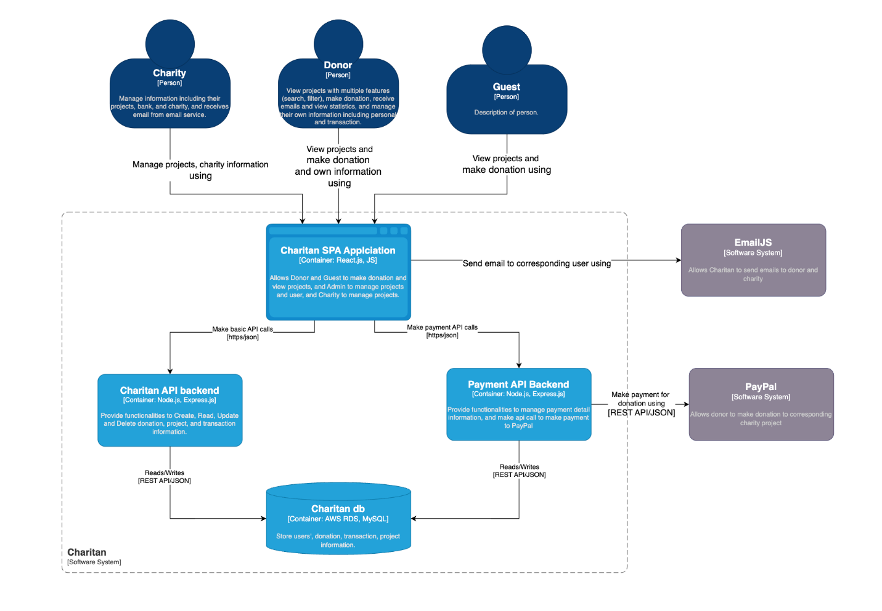

* System Level Architecture Diagram
* Description of Major Subsystems
* Integration Points with External Systems
* Communication Patterns

## 2. Backend Architecture(Trong):

* Backend Component Diagram
* Description of Key Components
* Controllers
* Services
* Repositories
* Utilities & Configurations
* Component Interactions
* Layer Organization (N-Tier Architecture)
* Presentation Layer
* Business Logic Layer
* Data Access Layer
* Repository Layer

## 3. Frontend Architecture(HB):

* Frontend Component Diagram

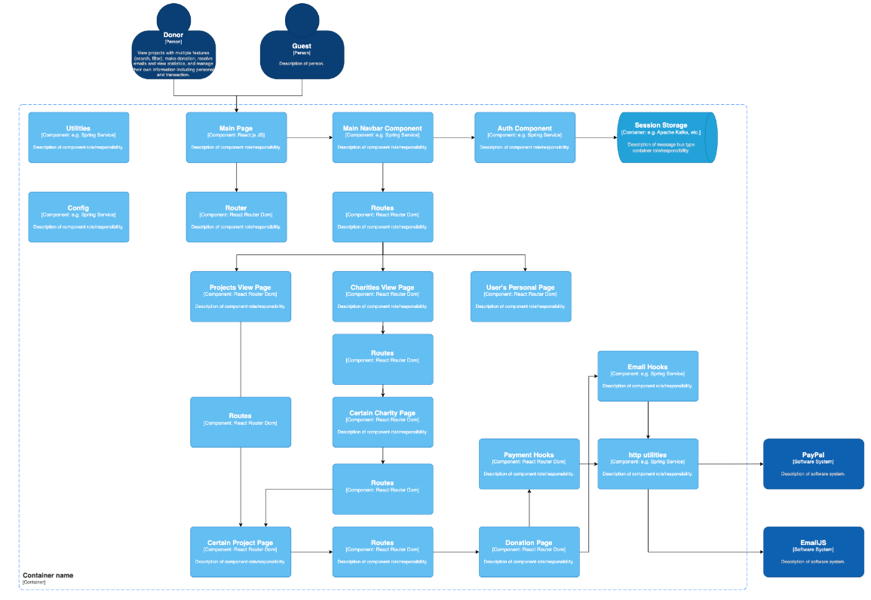di

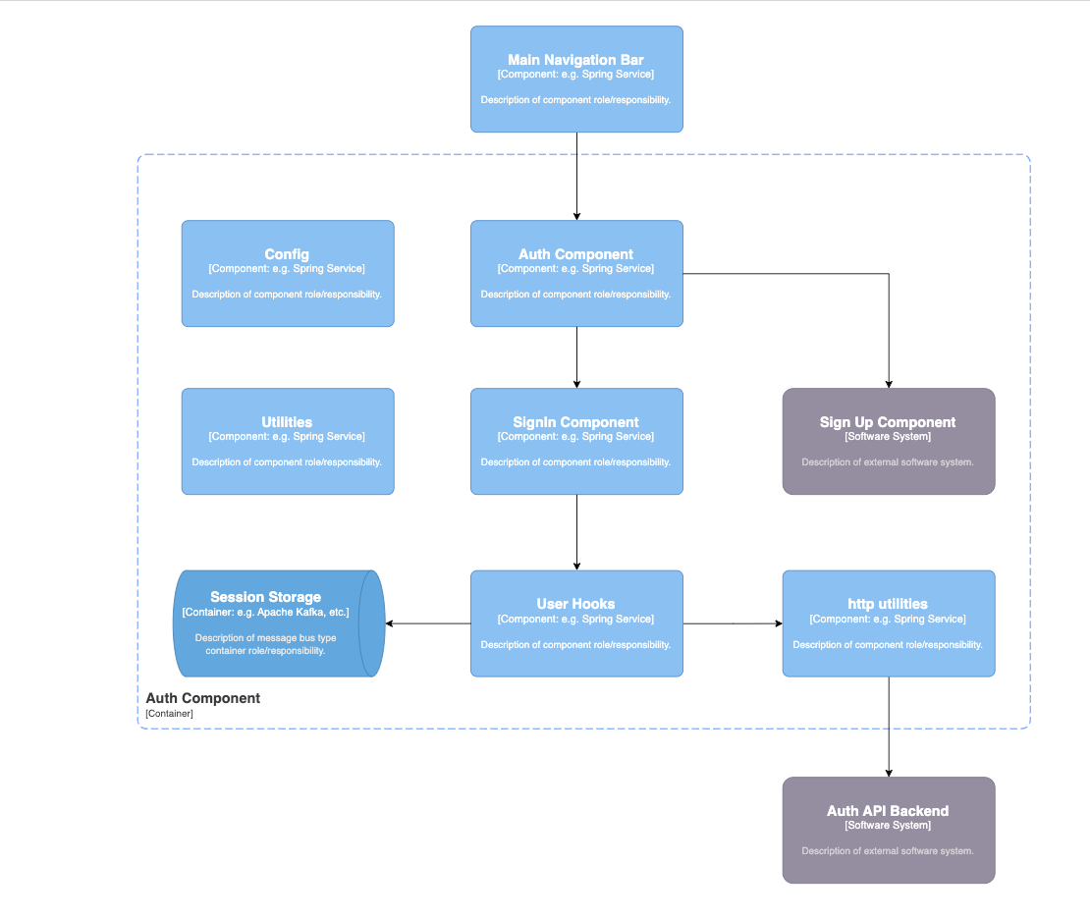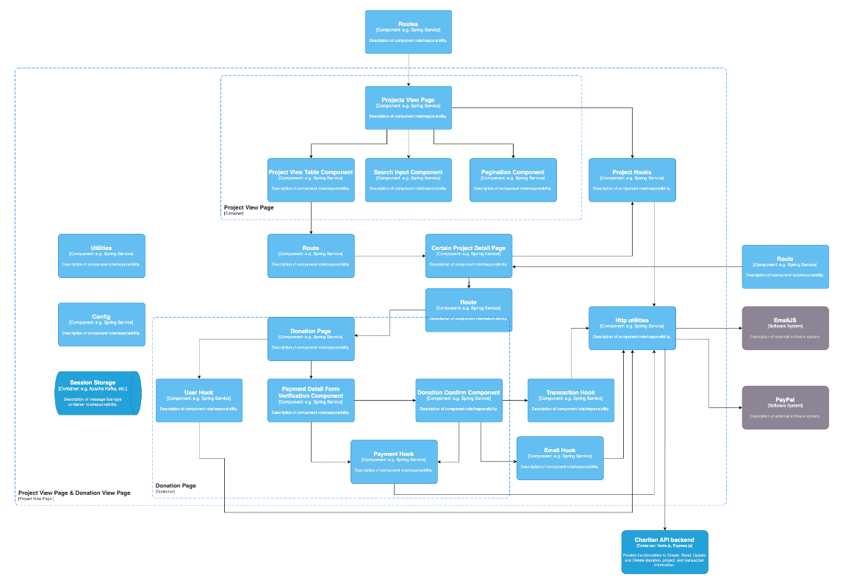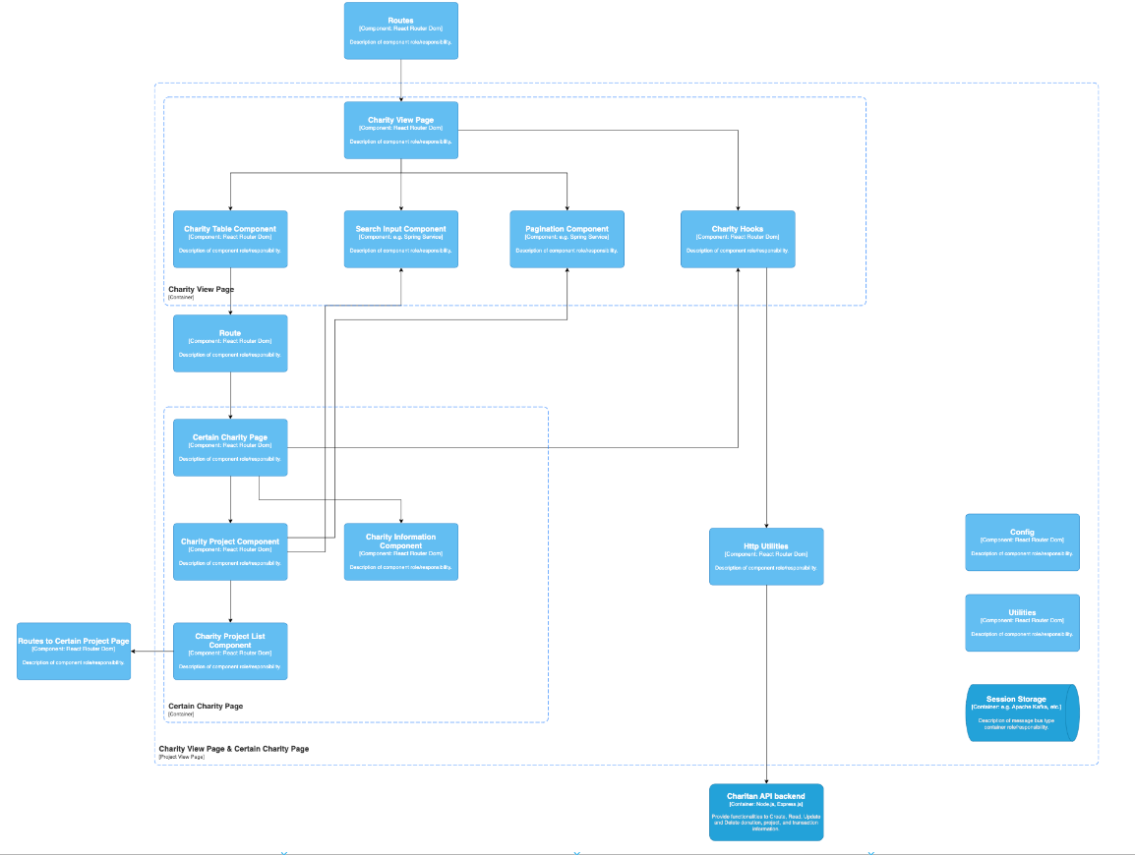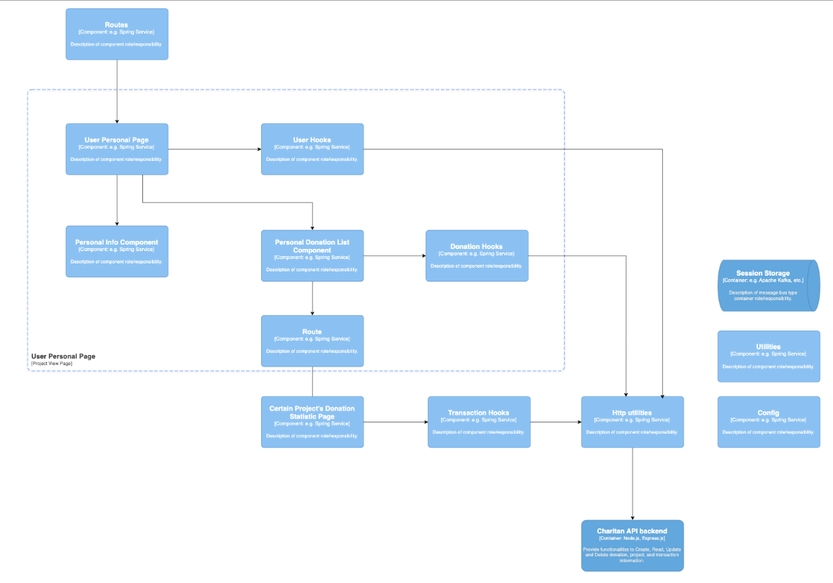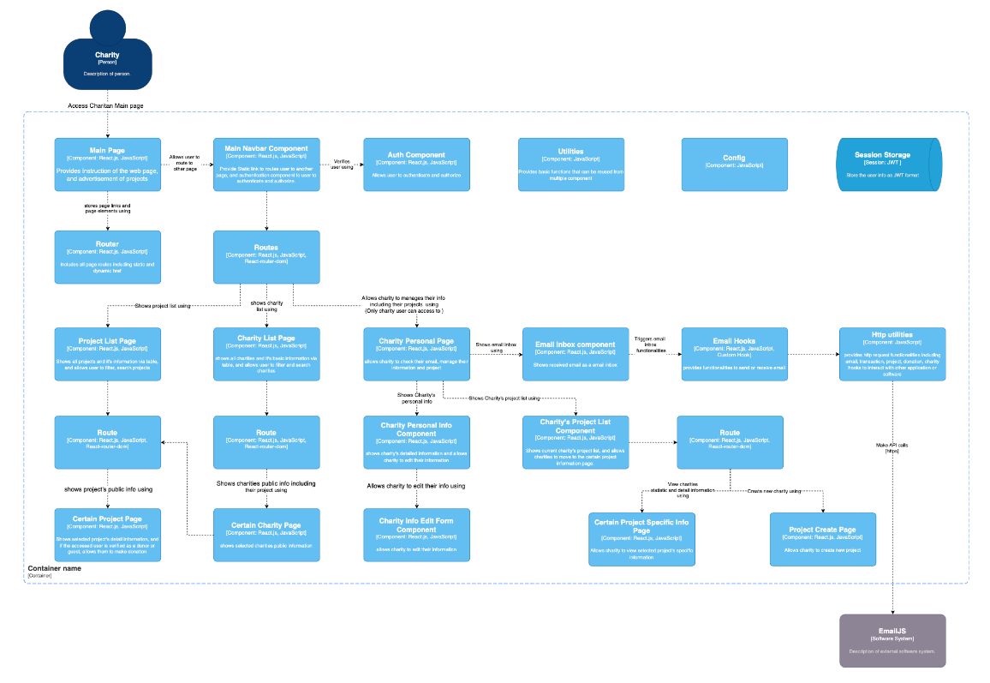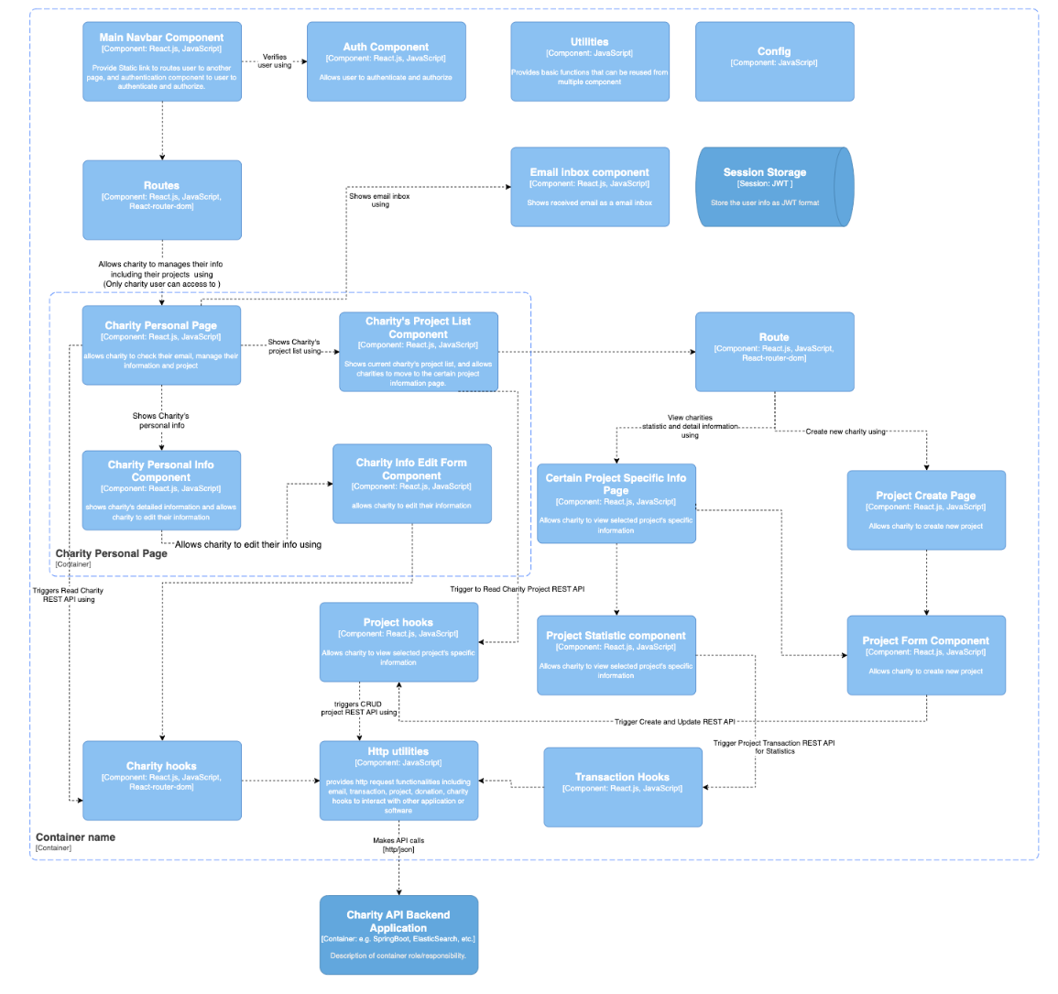

* Description of Key Components
* Pages/Views
* Components
* Services
* Utilities
* Component Interactions
* integration with Backend

# V. Architecture Analysis:

## 1. Maintainability:

Maintainability is essential for the sustained success of the Charitan platform. To guarantee the platform's robustness, scalability, and adaptability for future requirements, the following maintainability factors are taken into account:

* Design choices for maintainability:
* Modularity: The platform will feature modular architecture, deconstructing functionalities into autonomous, reusable components. This method enhances code reusability, facilitates upgrades, and isolates potential problems, so rendering maintenance more feasible.
* Loose Coupling: Components will exhibit minimal interdependencies, hence reducing their coupling. This mitigates the ripple effect of modifications, facilitating the alteration of one component without impacting others.
* Abstraction will conceal intricate implementation details behind transparent interfaces. This enhances comprehension of the code and mitigates the danger of unforeseen repercussions during modifications.
* Compliance with Standards: Coding standards and style guides will be rigorously implemented to guarantee uniformity and clarity throughout the codebase. This facilitates comprehension and maintenance of the code for developers, regardless of whether they were the original authors.
* Documentation: Thorough documentation will be developed and upheld, encompassing design documents, API specifications, and code annotations. This assists developers in comprehending the system and implementing informed modifications.

## 2. Extensibility:

* Component modularity
* Interface design
* Future enhancement capabilities

## 3. Resilience:

* Error handling
* Failure recovery
* System redundancy

## 4. Scalability:

* Load handling
* Resource management
* Performance optimization

## 5. Security:

* Authentication/Authorization
* Data protection
* Security measures

## 6. Performance:

* Response time optimization
* Resource utilization
* Caching strategies

# VI. Conclusion:

# References:

[1] “Three research essays on the effects of charity website design on online donations - ProQuest,” *Proquest.com*, 2014. <https://www.proquest.com/openview/2df8f28791552f9c5074e67ab029ec6d/1?pq-origsite=gscholar&cbl=18750> (accessed Nov. 27, 2024).

*[Refactoring - Improving the Design of Existing Code](https://silab.fon.bg.ac.rs/wp-content/uploads/2016/10/Refactoring-Improving-the-Design-of-Existing-Code-Addison-Wesley-Professional-1999.pdf) (for architectural analysis part)